A STUDY ON BRAND AWARENESS OF JCB WITH REFERENCE TO SRI SAI EARTHMOVERS

INDEX

CHAPTER | TITLE OF THE CONTENT | PAGE NO
1 | EXECUTIVE SUMMARY | 1
2 | INTRODUCTION | 3
3 | ORGANIZATION PROFILE | 7
4 | LITERATURE REVIEW | 22
5 | RESEARCH METHODOLOGY | 40
6 | DATA ANALYSIS AND INTERPRETATION | 43
7 | FINDINGS AND CONCLUSION | 65
 | BIBLIOGRAPHY | 69
 | QUESTIONNAIRE | 71

CHAPTER-1

EXECUTIVE SUMMARY

The project work finds out the brand awareness of JCB in the current scenario
I have undertaken this project to understand customer behavior towards JCB brand. This project is focused on Brand awareness of JCB, perception of customer towards JCB machine, promotion activity carried out by Sri Sai Earthmovers. The project scope is limited to Vijaypur. The survey was conducting using questionnaires and the information about various attributes and factor are collected.
It was totally a great experience to entering into the company. I spent most time in visiting different department and intreated with mangers, employee and costumer. It was able to understand company has created good brand image vijayapur city. And each department are contributing towards the achievement of the company goal.

The data is collected from primary source: customer. Data is filtered and analyzed, represented in the forms of graph. Secondary data was also used in report such as company profile, product profile etc. on the base of analysis the data, conclusion was drawn.

From the collection of data, I have found some important findings drawn in below
- Customer are very satisfied with JCB brand.
- Customer are given rating as an excellent to JCB.
- Respondents first choice when they think the JCB machine.
- Most of respondents prefer to use JCB machine.

Suggestion is given below:
- Increase the customer in both commercial and agriculture sector.
- JCB company as conduct the campaign in rural area.
- Make more advertisements on generators machine.
The survey gave knowledge about customer satisfaction, loyalty and feel about the brand. The survey gave your insight market of JCB.

CHAPTER -2

INTRODUCTION

Industry Profile
JCB is founded by Joseph Cyril Bamford in 1945.JCB is actually named J.C. Bamford Excavators Ltd and is a British multinational corporation, with headquarters in Rocester, Staffordshire. founded in 1945 and based in Rocester, Staffordshire, England was named after the initials of the name of its founder Joseph Cyril Bamford. the company continues to be owned by the Bamford family is a British manufacturer of equipment for construction, agriculture, waste handling, and demolition.

Background study of JCB India
JCB India Limited is a leading manufacturer of earthmoving and construction equipment in India. The company started as a joint venture in 1979 and is now a fully owned subsidiary of J.C Bamford Excavators, United Kingdom. With five state-of- the-art factories in India, it today manufactures a wide range of world-class equipment, not only for India, but also for Global markets.
JCB, the world's third largest construction equipment manufacturer has 21 plants in four continents: 12 in the UK, 5 in India and one each in the USA, China, Germany, and Brazil. Continuing the JCB heritage, Sir Anthony Bamford, Chairman, envisaged the India growth story back in 1979 and set up a joint venture company in the country to build machines which would eventually help build India’s growth. In 30 years, the company has grown to become a household name for all involved in the infrastructure industry. In any corner of the country, one is never far from a JCB. What has led to this huge success and sales of over 90,000 machines in India? NBM&CW's editorial team had the opportunity to interact with the higher echelons of JCB, Mr. Vipin Sondhi (CEO & MD), Mr. Arjun Mirdha (Executive Vice President, Sales & Marketing) and Mr. Amit Gossain (Associate Vice President, Marketing & Business Development) to know the evolution of JCB and how it's becoming a household name in country's infrastructure space.

Early Years
In 1948, six people were working for the company, and it made the first hydraulic tipping trailer in Europe. In 1950, it moved to an old cheese factory in Rocester, still employing six. A year later, he began painting his products yellow. In 1953, his first backhoe loader was launched, and the JCB logo appeared for the first time. It was designed by Derby Media and advertising designer Leslie Smith. In 1957, the firm launched the "hydra-digga", incorporating the excavator and the major loader as a single all-purpose tool useful for the agricultural and construction industries.
By 1964, JCB had sold over 3,000 3C backhoe loaders. The next year, the first 360- degree excavator was introduced, the JCB 7. In 1978, the Loadall machine was introduced. The next year, JCB started its operation in India. In 1991, the firm entered a joint venture with Sumitomo of Japan to produce excavators, which ended in 1998. Two years later, a JCB factory was completed in Pooler near Savannah, Georgia, in the US, and the next year a factory was opened in Brazil.
In 2005, JCB bought a company, purchasing the German equipment firm Vibromax. In the same year, the firm opened a new factory in Pudong, China. of a new
£40 million JCB Heavy Products site began following the launch of an architectural design competition in 2007 managed by RIBA Competitions, and by the next year, the firm began to move from its old site in Pinfold Street in Uttoxeter to the new site beside the A50; the Pinfold Street site was demolished in 2009. During that year, JCB announced plans to make India its largest manufacturing hub. Its factory at Ballabgarh in Haryana was to become the world's largest backhoe loader manufacturing facility. JCB shed 2,000 jobs during the 2008 global financial crisis; in 2010 it rehired up to 200 new workers.
In 2013, JCB set up its fourth manufacturing facility in India. In 2014, it was reported that three out of every four pieces of construction equipment sold in India was a JCB, and that its Indian operations accounted for 17.5% of its total revenue. JCB-based memes have also become prevalent in India.

Innovation milestones
- 1949: JCB Major Loader revolutionises agriculture.
- 1952: JCB backhoe loader is born with the Mk 1 Excavator.
- 1963: JCB 3C takes backhoe performance to new levels; a design classic.
- 1964: JCB 7 becomes JCB's first crawler excavator.
- 1971: JCB 110 hydrostatic crawler loader proves our pioneering spirit.
- 1977: JCB 520 telescopic handler, a new concept, takes the industry by storm.
- 1980: JCB 3CX marks the construction industry's largest investment in a single machine.
- 1990: JCB Fastrac becomes the world's first fully suspended, high-speed draught tractor.
- 1993: JCB robot skid steer loader becomes the world's safest skid steer.
- 1997: JCB Teletruk takes the industry by storm.
- 2006: 2 JCB 444 diesel engines power the JCB Dieselmax to the diesel word land speed record.
- 2010: JCB Eco machines take machine efficiency and productivity to new world-beating levels.
JCB Manufacture Plant
JCB now has five factories in India in addition to 12 in the UK and others in Brazil, China and the USA. JCB India is a leading manufacturer of construction equipment and its factory near Delhi produces backhoe loaders and engines. And also, The Ballabgarh factory near New Delhi, which is the world's largest factory for Backhoe Loaders, is also the Headquarters for JCB India.

Indian Dealers
Having a pan India existence with 650+ dealers’ network, trained & skilled service engineers, and parts availability, JCB is one of the leading market players that understands your business needs.

CHAPTER-3

ORGANIZATION PROFILE

COMPANY PROFILE

Sri Sai Earthmovers was started on 1/1/2013 and Sri Sai Earthmover was authorized by JCB India and its range of product of Gulbarga, Vijaypur, Bidar, Raichur and Yadgeri with the head office Gulbarga Karnataka Sri Sai Earthmovers JCB dealership a complete range of service including equipment sale and genuine JCB part to its customer across Gulbarga, Vijaypur, Bidar, Raichur and Yadgeri in Karnataka.

COMPANY MANPOWER
The Sri Sai Earthmovers JCB dealership current employees out of 15 are on sale 70 for service and for backend operation. Over the year the Sri Sai Earthmovers JCB dealership has established it’s as a trusted name as a JCB dealership in the around district of Gulbarga, Vijaypur, Bidar, Raichur and Yadgeri in Karnataka.

NATURE OF THE COMPANY
JCB is a heavy equipment industry. And widely range and it has target costumer involving for example Construction, Agriculture, waste handling and demolition machinery etc.

MISSION
Sri Sai Earthmovers mission is to make a reach the target which given by the company. And make the best dealer across Gulbarga, Vijaypur, Bidar, Raichur and Yadgeri.

VISION
Sri Sai Earthmovers ensure that costumer should get good service and satisfied the need and want of customer across Gulbarga, Vijaypur, Bidar, Raichur and Yadgeri in Karnataka.

geographical map of the proposed area:

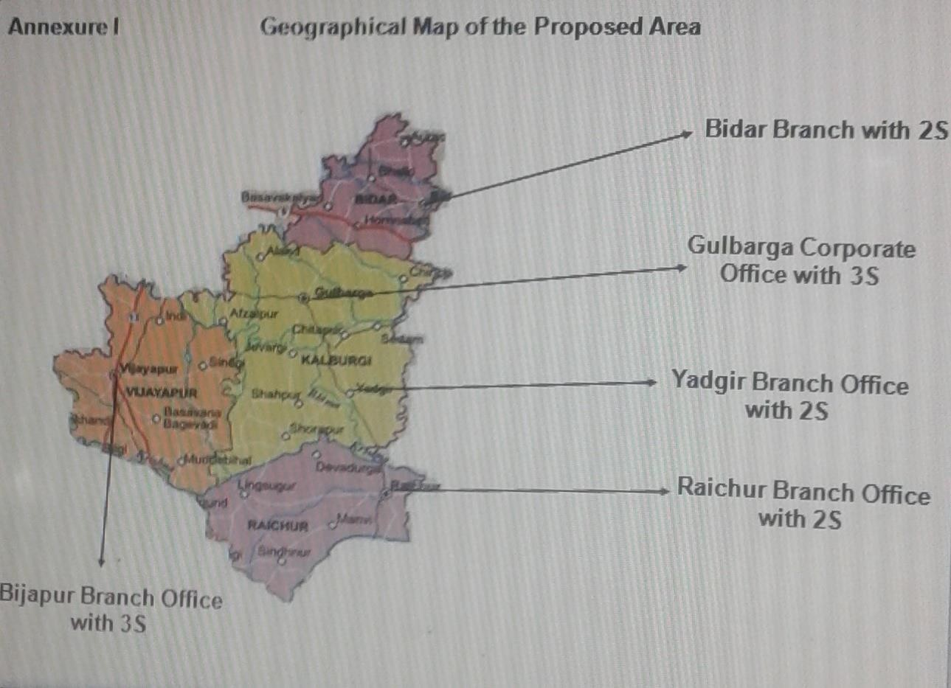
























ORGANIZATION STRUCTURE:
Managing partner
GM
Sales
GM
Service
Spare parts Manager
Account HR Manager Manager
Sales Coordinator
Manager Sales
Gulbarga
Manager Sales
Vijaypur
Manager Service Gulbarga
Manager Service Vijaypur
All Parts
Service Engg Gulbarga
Warranty Incharge
Warranty Incharge
Service Engg Vijaypur
Service
Service Technicians

SERVICE DEPARTMENT:
Sri Sai Earthmovers is giving best service to the costumers across Gulbarga, Bijapur, Bidar, Raichur and Yadgeri in Karnataka.

Service Department Routine Work:
The service department is work is to see PDI(Pre Delivery Inspection) it means once the machine comes to the official service department, then the service department work is to make an inspection of the JCB machine to check that the machine is working properly.

Service Given After the Machine Purchase:
Once the customer has purchased the JCB machine, the machine installation will be done by the service team in the costumer place, then after 1 month, JCB worker will visit the customer place to check whether the machine is working properly or not.
Free services after purchase machine.
- 1st service after 100 hours
- 2nd service after 500 hours
- 3rd service after 1000 hours
- 4th service after 1500 hours
- 5th service after 2000 hours Warranty Given by Company:
- Standard warranty – 1 year
- Engine warranty – 2 years

Claim Given to Company:
JCB machine purchased by the customer if damages happen to JCB machine they show the warranty make a repair it will claim by JCB India company.
Sri Sai Earthmovers has given on side service given to the customer some process as follow:
Compliant has taken from CRM software which is using in the company
- Service steps:
- Call open
- assign
- Fixed
- Close

Parts Department:
Sri Sai Earthmover’s giving all type of part to the customer across Gulbarga, Bijapur, Bidar, Raichur and Yadgeri in Karnataka.

Parts are purchased from the JCB India LTD Place Where Purchase:
- Chennai
- Kolkata
- Pune
- Faridabad

Process for Giving Order:
- Make the order
- It will go to Pune
- They will send the part
- Make the inward

Oil is purchased from Bangalore and The process of giving the order:
- Order the oil
- It will go to Bangalore
- They will send the oil
- Make the inward
An extra feature in part department:
TOC – (Theory of constant) it has an app which helps automatically order the part if 10 part send 70% of part sold it will automatically order a part to the company

Sales Department:
Sri Sai Earthmovers ensure that whatever the given the target on sale we can possible to make to reach that target and satisfied need and want of costumer.
Company Focus on Target Customer: Construction
Agriculture
Waste handling etc.

Information of JCB machine:
Sale department work is to give the full information about the JCB machine and giving the information about the extra feature in JCB machine which the customer makes a plan to buy the machine.
Sale executive works:
Sale executive workflow is as follows:
Sale executive work is to give full information about JCB machine Sale executive work is to share the benefits of JCB Company

Finance Department:
Sri Sai Earthmover’s in the Finance department manage its money. The business function typically included planning, organizing, control its company finances. Work of Finance department:
Finance department works is to divide the amount properly and make ensure that not the message of the amount and make proper written is a book which amount is for the business.
Private Finance:
- HDFC
- HDB Finance
- Sherya Finance
- Sri Ram Finance
- National banks:
- Karnataka banks
- SBI bank
- DCC bank
- All co-operative bank

HR Department:
HR department work is to make the manpower in the organization& select the right man in the right place & also make or other works.
The HR department is on focused on a number of majors are including.
- Recruiting staff
- Leave permission
- PF ESI maintains
- Office maintains
- Office rules & regulation
The HR department is also conducting the training for the new employee how are working in the organization.

Account Department:
Account department work is to record the transaction which has done in the organization and maintaining the petty cash book and cash book which are using in the organization.
In the accounting department, they are maintaining following
- Petty cash book
- Cash book
- Petty cash book: In the petty cash book, they have written daily expenses which have done in the organization
- Cashbook: In the cash book, they have written in incomes and expenses daily which have happened in the organization like
- Service Amount
- Booking amount
- Part amount,
- Lubricant amount etc

PRODUCT PROFILE:

3DXBHL (33 Lakh)
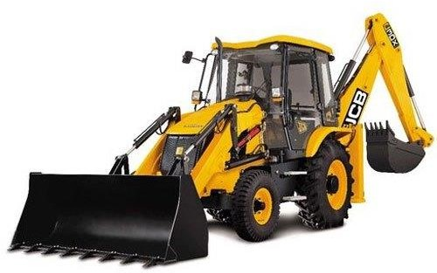
Features:

Brand | JCB
Model Name/Number | 3DX Xtra EcoXpert
Max Pump Flow Rate | 128 LPM
After Sales Service Available | Yes
Reach Ground Level To Rear Wheel Center | 6.93 m
Reach Ground Level To Slew Center | 5.61 m

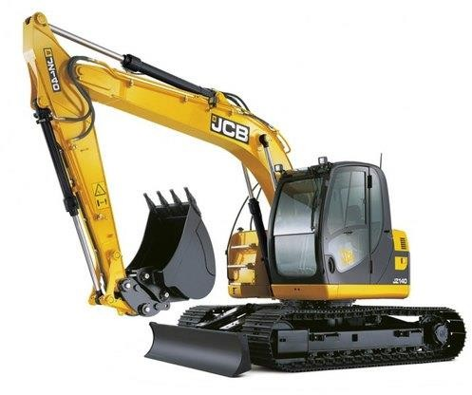
JS 140 (35 lakh)

Features:

Brand | JCB
Excavator Model | JS140
Maximum Operating Weight | 14320 kg
Maximum Engine Power | 100 hp
Maximum Bucket Capacity | 0.72 m³
Max digging depth | 5150 mm

JS220 (Rs 58 lakh)

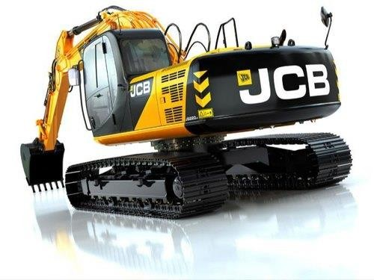
Feature:

Engine Type | 4-stroke, 4-cylinder In-line, Direct Injection, Turbocharged Diesel
Ground Clearance | 503
Engine Piston Displacement | 4.8 L
Track Height | 885
Transport Height With  Monoboom | 3070
Undercarriage Overall Length | 4460

Soil compactor Rs23.50 lakh

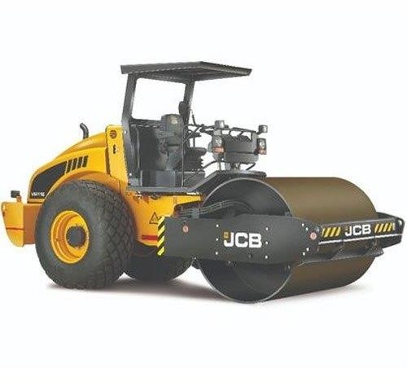
Features:

Model/Type | JCB VM 116
Brand | JCB
Engine Power | 108 HP @ 2400 rpm
Amplitude | High 1.72 mm, Low 0.8 mm
Max Operating Weight | 11950 Kgs
Working Speed | 0-9 Km/hr

JCB Generator (8 lakh)

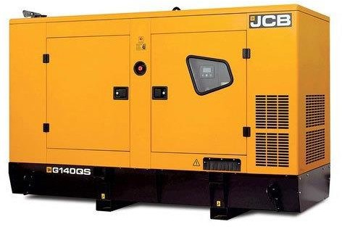

Feature:

Genset Rating | 62.5 KVA to 200 KVA
Brand | JCB DG set / Generators / Genset / Diesel  Generators
Cooling System | Water Cooling, Water Cooled
Model | Please refer enclosed JCB DG set Catalogue
Fuel Consumption (at 100% Load) | Please refer enclosed JCB DG set Catalogue
Phase | Three Phase

SWOT ANALYSIS

Strength:
- Huge product line
- Service the wide range of sector
- Superior customer service
- Market leader in construction
- International presence

Weaknesses:
- High dependence on other countries
- High maintenance cost
- Lack of diversification

Opportunities:
- Emerging market
- Product leverage
- Expansion of factories

Threats:
- Heavy headwinds
- Dependency on other sectors

CHAPTER-4

LITERATURE REVIEW

LITERATURE REVIEW:

Sebastian Molinillo (13 April 2016): Responsible brands as compared with active brands? In an examination of brand personality on brand awareness, brand trust, and brand loyalty, there is an ascent interest between experts and academics on the subject of consumer brand relationships. The Customer’s relationships are important to be built with brand an identity consistent with their own. The reason for this research paper is to examine two kinds of brand personality traits, to be specific, responsible brands and dynamic brands to anticipate conspicuous CBR develops, brand awareness, brand loyalty and brand trust included.
Jenni Romaniuk (30 June 2016), Revisiting an old metric for a new world, brand awareness is an important, but often neglected, aspect of consumer-based brand equity. This research paper returns to measure brand awareness with regards to worldwide brand the management. And which help Taking a look at the strategy for Laurent et al. (1995), this longitudinal cross-section examines and inspects modification in brand awareness after some time, with size of test around 300 whisky customers for each wave in 3 nations: United Kingdom, Greece and Taiwan
Ulrich Doraszelski, C. Robert Clark, Michaela Draganska (8 May2009),The effect of Advertising on brand awareness and perceived quality and they use board informational set that consolidates yearly brand-level advertising expenditure for more than three hundred brands with proportions of brand awareness and perceived quality from a large-scale buyer study to examine the impact of promoting. The advertising is display as a dynamic investment in a brand's stocks of perceived quality and awareness and we ask how such a venture changes brand awareness and quality recognitions
Kevin Lane Keller (1 March 2003), Brand Synthesis: The Multidimensionality of Brand Knowledge and Journal of Consumer Research, Volume 29,. Increases the need put on marking by marketers as of late offers an opportunity for purchaser analysts to give profitable experiences and direction. Specifically, it is exceptionally focused market place, marketers regularly should interface their brands to different substances, for example, individuals, spots, things, or different brands, as a way to improve their brand value. And Understanding this utilizing procedure requires understanding buyer brand information and how it changes from such association.’

Jumiati Sasmita (March 2005) Effects of brand association, brand loyalty, brand awareness, and brand image, Journal of Retail & Distribution Management, . The reason for this is the project paper look at impacts of brand affiliation, brand awareness, brand loyalty, and brand picture on brand value amongst young purchasers. The Information from 200 young shoppers were investigated using descriptive, multiple regression and correlation examination by means of the Statistical Package for Social Sciences PC program rendition. from the Observational outcomes by means of numerous regressions confirmed that brand awareness dominatingly influences brand value amongst young customers. These all-young buyers gaining input and awareness from social life about the particular item or brand.
Gilles Laurent, Raphaëlle Lambert-Pandraud, Carolyn Yoon, Etienne Mullet, (June 2017) Impact of age on brand awareness sets: a turning point in consumers’ early 60s, Marketing Letter. Age affects the brands a shopper knows, that, the "set of awareness " which fundamentally decides brand decision and consideration. The Brands are in the middle of normal things and appropriate names yet past psychology inquire about offers conflicting results on the effect of age on learning of basic nouns vs. proper names. Our all-observational investigation on radio stations demonstrates that age direct affects set of awareness is set apart by a defining moment in consumer’s early 60’s, with 2 differentiated patterns.
The Role of Brand Awareness in Heavy Equipment Industry
Brand awareness is a crucial factor in the heavy equipment industry, as it directly influences customer preference and purchase decisions. According to Keller (1993), brand awareness consists of brand recognition and brand recall, which play a vital role in shaping consumer perceptions. In the construction equipment sector, companies like JCB leverage their strong global reputation to maintain a competitive edge. Studies by Aaker (1996) suggest that high brand awareness leads to increased consumer trust and loyalty, particularly in industries where reliability and performance are paramount.
JCB, a globally recognized brand, benefits from extensive marketing efforts, word-of-mouth recommendations, and a strong distribution network. Research by Kotler and Keller (2016) highlights that in B2B markets, brand awareness is driven by consistent quality, after-sales service, and dealer support. Sri Sai Earthmovers, as an authorized dealer, plays a critical role in shaping customer perceptions through service excellence and personalized interactions. Previous studies emphasize that a well-known brand significantly reduces perceived risk, leading to higher customer retention rates. Thus, for JCB, maintaining brand awareness through dealers like Sri Sai Earthmovers is essential for sustaining its market dominance.
The Impact of Dealer Network on Brand Awareness
The role of dealership networks in enhancing brand awareness is extensively discussed in marketing literature. According to Berry (2000), dealerships act as a bridge between manufacturers and end-users, significantly influencing how a brand is perceived in the market. In the case of JCB, authorized dealers such as Sri Sai Earthmovers contribute to brand recall by offering excellent service, localized marketing, and customer engagement.
A study by Zeithaml, Bitner, and Gremler (2017) states that dealerships are a critical touchpoint where potential buyers interact with the brand. In industrial markets, where the purchase decision involves significant investment, dealer interactions play a decisive role. Research by Chattopadhyay and Laborie (2005) emphasizes that personalized service and demonstration of equipment performance enhance consumer trust and loyalty. Sri Sai Earthmovers, as a trusted dealer, contributes to JCB's market visibility through promotional activities, field demonstrations, and customer education programs.

Furthermore, studies in brand equity suggest that a well-managed dealer network can strengthen customer relationships, thereby enhancing brand recall (Keller, 2008). This indicates that JCB's sustained brand awareness is not just a result of corporate branding efforts but also the localized marketing strategies implemented by its dealers.

Influence of Advertising and Digital Marketing on Brand Awareness
The advent of digital marketing has reshaped brand awareness strategies, particularly in the B2B sector. Research by Kotler and Armstrong (2018) highlights that a brand’s online presence significantly impacts its recognition and consumer engagement. In the case of JCB, digital marketing, coupled with traditional advertising, plays a crucial role in sustaining brand awareness.

A study by Hollensen (2019) points out that digital marketing strategies, such as search engine optimization (SEO), social media engagement, and targeted advertisements, enhance brand visibility among potential buyers. JCB’s strong presence across multiple digital platforms, including LinkedIn, YouTube, and industry-specific portals, has contributed to higher brand recall. Moreover, localized promotional efforts by dealers like Sri Sai Earthmovers further amplify JCB’s market reach.

According to a study by Lee and Park (2020), online reviews, testimonials, and customer engagement on digital platforms significantly influence purchasing decisions in the construction industry. Dealers who actively participate in digital marketing initiatives contribute to higher brand recall and customer trust. Thus, Sri Sai Earthmovers’ digital engagement efforts, combined with JCB’s global marketing strategies, enhance overall brand awareness and market penetration.

Customer Perception and Brand Loyalty in Construction Equipment
Customer perception plays a vital role in establishing brand awareness and long-term loyalty in the heavy machinery industry. According to Aaker (1991), brand awareness is the foundation of brand equity, influencing consumer preference and willingness to pay a premium price. In the case of JCB, its reputation for durability and efficiency significantly impacts buyer perception.

A study by Oliver (1999) indicates that brand loyalty is a direct outcome of customer satisfaction and perceived brand value. In the industrial equipment sector, repeat purchases and positive word-of-mouth significantly strengthen brand awareness. Research by Rust, Zeithaml, and Lemon (2004) further suggests that trust in a brand’s performance leads to stronger emotional connections, thereby reinforcing brand recognition.

Sri Sai Earthmovers, as a JCB dealer, contributes to customer trust by offering exceptional after-sales service and personalized support. Studies in service marketing indicate that dealer interactions play a significant role in shaping customer experiences, directly impacting brand recall (Parasuraman, Zeithaml, & Berry, 1988). Therefore, maintaining high service quality and strong dealer-customer relationships is key to sustaining JCB’s brand awareness in the competitive market.

Word-of-Mouth Marketing and Its Effect on Brand Awareness
Word-of-mouth marketing (WOM) is one of the most influential factors in building brand awareness, particularly in industrial markets. According to Keller (2003), positive customer experiences and recommendations significantly impact brand recall and trust. In the case of JCB, referrals from existing customers play a major role in shaping market perceptions.

Research by Brown and Reingen (1987) emphasizes that in high-involvement product categories like construction equipment, personal recommendations carry greater weight than traditional advertising. JCB’s reputation for reliability has been strengthened over the years through strong customer advocacy. A study by Chevalier and Mayzlin (2006) highlights that word-of-mouth marketing, particularly in local markets, leads to higher consumer engagement and brand recall.

Sri Sai Earthmovers, as a regional dealer, plays a significant role in facilitating positive customer interactions. By ensuring excellent service, prompt response times, and reliable product demonstrations, the dealership enhances JCB’s reputation in the local market. Studies on brand awareness suggest that businesses with strong word-of-mouth endorsements achieve higher customer retention and long-term brand loyalty (Berger & Schwartz, 2011). This underscores the importance of local dealerships in driving brand awareness through customer advocacy and service excellence.

The Evolution of Brand Awareness in the Construction Equipment Industry
Brand awareness has undergone significant transformation in the construction equipment industry due to changing market dynamics and evolving consumer behavior. Early research by Aaker (1991) defined brand awareness as a crucial component of brand equity, arguing that a strong brand presence in the consumer’s mind increases trust and preference. This concept has been further expanded by scholars such as Keller (2013), who highlighted that brand awareness is not only about recognition but also about the ability to associate a brand with a particular need.

In the case of JCB, the company has established itself as a leading global player in construction and earthmoving equipment. Studies by Balmer (2012) suggest that industrial brands like JCB maintain strong awareness through a combination of corporate branding, dealer partnerships, and product reliability. Sri Sai Earthmovers, as a regional dealer, contributes to reinforcing JCB’s market dominance by ensuring consistent product availability and service quality. Research by Morrison and Crane (2007) highlights that localized marketing efforts, including dealership promotions and customer engagement initiatives, significantly boost brand awareness. Therefore, the synergy between JCB’s global branding strategies and Sri Sai Earthmovers’ local outreach ensures strong customer recall and long-term brand loyalty.

The Impact of Corporate Social Responsibility (CSR) on Brand Awareness
Corporate Social Responsibility (CSR) has emerged as a powerful tool for enhancing brand awareness in industrial sectors, including the construction equipment industry. Research by Porter and Kramer (2011) suggests that companies engaging in CSR activities enjoy increased brand recognition, consumer trust, and competitive advantage. JCB has actively participated in CSR initiatives such as environmental sustainability programs, skill development initiatives, and infrastructure projects, all of which contribute to a stronger brand image.

A study by Mohr, Webb, and Harris (2001) emphasizes that ethical business practices and social contributions significantly enhance a company’s credibility. In the context of JCB, its efforts in promoting sustainable construction equipment and worker safety have positively influenced brand perception. Sri Sai Earthmovers, as an authorized JCB dealer, also plays a role in reinforcing this image by aligning with JCB’s CSR initiatives and ensuring that customers perceive JCB as a socially responsible brand. Research by Bhattacharya and Sen (2004) further highlights that CSR-driven brand awareness is particularly strong when local dealers actively participate in community development and customer education programs. This indicates that Sri Sai Earthmovers' involvement in local CSR efforts can enhance JCB’s brand awareness at a regional level.

The Influence of Brand Positioning on Awareness and Market Leadership
Brand positioning is a critical factor that influences awareness and competitive success in industrial markets. According to Ries and Trout (1981), brand positioning involves creating a distinct image in the consumer’s mind, which differentiates a company from its competitors. JCB has successfully positioned itself as a premium brand in the construction equipment industry through innovation, quality, and superior after-sales service.

Research by Kapferer (2012) indicates that companies with a well-defined brand positioning strategy enjoy higher brand recall and customer loyalty. JCB’s positioning as a technologically advanced and durable brand aligns with customer expectations in the construction industry. Additionally, studies by Kotler and Keller (2016) highlight that brand positioning is strengthened by a strong dealer network that reinforces brand values. Sri Sai Earthmovers, through its service excellence and market expertise, plays a crucial role in communicating JCB’s brand positioning to customers. By providing tailored solutions, technical assistance, and after-sales support, the dealership enhances customer confidence in the JCB brand. This localized positioning strategy ensures that JCB remains a top-of-mind brand among potential buyers in the region.
The Role of Customer Engagement in Enhancing Brand Awareness
Customer engagement has become an essential factor in building brand awareness, particularly in industrial sectors where purchase decisions are high-involvement. Research by Brodie et al. (2011) defines customer engagement as the level of customer interaction and emotional connection with a brand. For JCB, active engagement with customers through trade shows, demonstrations, and service support has significantly contributed to its strong brand recall.

A study by Vivek, Beatty, and Morgan (2012) suggests that higher customer engagement leads to stronger brand advocacy, meaning satisfied customers are more likely to recommend the brand to others. In this regard, Sri Sai Earthmovers plays a pivotal role in strengthening JCB’s brand awareness by facilitating customer engagement through hands-on product demonstrations, technical training, and prompt service responses. Additionally, research by Hollebeek (2011) highlights that digital engagement, such as social media interactions and online support forums, further enhances brand recognition and loyalty. Sri Sai Earthmovers, by leveraging both offline and online engagement strategies, contributes to ensuring that JCB remains a preferred brand among construction equipment buyers. This underscores the importance of direct dealer-customer relationships in sustaining brand awareness.
The Effect of Pricing Strategy on Brand Awareness in Industrial Markets
Pricing strategy plays a crucial role in determining brand awareness and market perception in industrial sectors. Research by Monroe (1990) suggests that pricing decisions not only influence customer purchase behavior but also impact how a brand is perceived in terms of quality and reliability. JCB, known for its premium pricing strategy, has established itself as a high-quality and durable brand in the construction equipment industry.

A study by Zeithaml (1988) highlights that customers often associate higher prices with better quality, especially in B2B markets where performance and longevity are critical factors. JCB’s pricing strategy is justified by its superior product reliability, innovative technology, and excellent after-sales support. However, research by Nagle and Müller (2017) suggests that price must be complemented by strong brand awareness efforts to justify the value proposition to customers. This is where Sri Sai Earthmovers plays a vital role by ensuring that customers understand the value of JCB’s pricing through product demonstrations, testimonials, and financial assistance options.
Additionally, studies in industrial marketing suggest that price-based promotions, bundled offers, and financing schemes enhance brand awareness by making products more accessible to potential buyers (Dutta, Bergen, & Levy, 2002). By implementing localized pricing strategies, Sri Sai Earthmovers contributes to reinforcing JCB’s brand positioning and awareness in the market.
Digital Marketing’s Influence on Brand Awareness in the Construction Equipment Sector
Digital marketing has become a crucial tool for enhancing brand awareness, even in industrial markets such as construction equipment. Kotler and Keller (2020) emphasize that digital branding strategies, including search engine marketing, social media engagement, and influencer collaborations, significantly improve a brand’s visibility. JCB has adopted digital marketing to reinforce its presence among contractors, construction firms, and individual buyers.
A study by Constantinides (2006) highlights that websites and online platforms play a pivotal role in shaping customer perceptions and trust. JCB’s well-structured website, featuring machine specifications, customer testimonials, and after-sales service details, strengthens its brand recall. Additionally, research by Chaffey and Smith (2017) suggests that social media campaigns enhance engagement and customer interaction, leading to stronger brand loyalty. Sri Sai Earthmovers, as a JCB dealer, benefits from online marketing by promoting JCB products through localized advertisements, WhatsApp marketing, and digital customer support.

Furthermore, Batra and Keller (2016) found that content marketing strategies, such as blogs and video demonstrations, significantly influence purchase decisions. By leveraging digital marketing channels, JCB and Sri Sai Earthmovers collectively enhance the brand’s awareness and ensure its competitive presence in the construction equipment industry.

Word-of-Mouth Marketing and Its Impact on Brand Awareness
Word-of-mouth (WOM) marketing has been a longstanding factor in shaping brand awareness and influencing purchase decisions, particularly in industrial markets. According to Arndt (1967), personal recommendations and direct customer experiences play a crucial role in brand recall and trust. In the construction equipment industry, where heavy investments are involved, customers rely heavily on peer reviews and expert opinions before making a purchase decision.

Studies by Godes and Mayzlin (2004) suggest that positive WOM increases a brand’s credibility and enhances its market positioning. JCB, known for its product durability and after-sales support, has successfully leveraged customer referrals to expand its market reach. Sri Sai Earthmovers, as an authorized JCB dealer, plays a key role in amplifying positive WOM by ensuring superior service, customer engagement, and technical assistance. Research by Berger and Schwartz (2011) highlights that brands with strong offline and online customer conversations tend to have higher visibility and stronger recall.

Furthermore, digital WOM, such as online reviews and ratings, has further strengthened JCB’s brand awareness in recent years (Chevalier & Mayzlin, 2006). By fostering positive customer relationships and leveraging referral programs, Sri Sai Earthmovers enhances JCB’s brand image and sustains long-term market trust.

Dealer Network’s Role in Strengthening Brand Awareness
The role of an extensive dealer network in building brand awareness is widely recognized in industrial marketing literature. According to Stern and El-Ansary (1992), dealerships serve as the direct link between manufacturers and customers, influencing customer perception and satisfaction. JCB’s global and regional dealer presence ensures widespread accessibility and service support, which enhances its brand recall.

A study by Anderson and Weitz (1992) emphasizes that a strong manufacturer-dealer relationship leads to improved customer trust and long-term brand loyalty. Sri Sai Earthmovers, as a dedicated JCB dealer, contributes to JCB’s brand awareness by offering personalized customer support, localized promotions, and on-ground product demonstrations. Research by Rosenbloom (2013) further suggests that dealerships play a key role in educating customers about product benefits and post-purchase services, thereby reinforcing brand reliability.

Additionally, Matthyssens and Vandenbempt (2008) argue that dealer-led marketing strategies, such as customer workshops and technical training sessions, further strengthen brand recall. By actively engaging with end-users and providing hands-on experiences with JCB machinery, Sri Sai Earthmovers ensures that JCB remains a top choice in the construction equipment industry.

The Role of After-Sales Service in Enhancing Brand Awareness
After-sales service is a critical factor in brand awareness, especially in high-involvement product categories like construction equipment. Research by Parasuraman, Zeithaml, and Berry (1985) suggests that superior after-sales support enhances customer satisfaction, leading to stronger brand loyalty and positive word-of-mouth marketing. JCB has built its reputation on providing excellent after-sales services, including maintenance support, spare parts availability, and technical assistance.

A study by Gaiardelli, Saccani, and Songini (2007) found that customers are more likely to recall and recommend a brand that offers prompt service and high spare parts availability. Sri Sai Earthmovers, as a JCB dealer, plays a crucial role in ensuring customer retention by providing timely service and product training. Research by Rust and Zahorik (1993) further highlights that after-sales service contributes to perceived product value, making brand recognition stronger in competitive markets.

Moreover, Johnston (1995) emphasizes that service quality directly impacts a brand’s image. By maintaining high service standards and ensuring customer satisfaction, Sri Sai Earthmovers strengthens JCB’s brand awareness and reinforces its market position. This illustrates that strong post-purchase support is not just a retention tool but a powerful branding strategy.

Emotional Branding and Customer Loyalty in Industrial Markets
Emotional branding, often associated with consumer goods, has been increasingly recognized as a key factor in industrial markets. According to Schmitt (1999), brands that create emotional connections with customers have higher recall and loyalty. While construction equipment brands like JCB primarily rely on functional value, research by Roberts (2004) suggests that emotional branding can differentiate brands in a competitive market.

Aaker (2012) highlights that trust, reliability, and long-term relationships form the foundation of emotional branding in B2B markets. JCB, through its legacy and reputation for quality, has cultivated an emotional connection with customers by positioning itself as a dependable brand in construction and infrastructure development. Sri Sai Earthmovers enhances this brand sentiment by offering personalized services, engaging with customers beyond transactions, and building long-term relationships.

Studies by Fournier (1998) indicate that customer-brand relationships in industrial sectors are built on assurance and consistency. By maintaining strong customer relationships, offering timely assistance, and reinforcing JCB’s commitment to quality, Sri Sai Earthmovers strengthens the emotional bond between customers and the JCB brand. This contributes to deeper brand awareness, long-term customer retention, and sustained market leadership.

Impact of Celebrity Endorsements on Brand Awareness in the Construction Equipment Sector
Celebrity endorsements are a well-known branding strategy in consumer markets, but their relevance in industrial sectors is gaining traction. According to Agrawal and Kamakura (1995), celebrity-backed advertisements significantly improve brand recall and trust. While construction equipment brands like JCB rely on product performance, endorsements by industry experts, influencers, or well-known corporate figures can enhance credibility.

A study by Till and Busler (2000) found that when a credible personality endorses a brand, consumer perceptions of quality and reliability increase. JCB has leveraged industry leaders and testimonials from well-known infrastructure firms to enhance its reputation. Sri Sai Earthmovers, as an authorized JCB dealer, reinforces this brand strategy by showcasing endorsements from satisfied contractors and engineers.

Furthermore, research by Erdogan (1999) suggests that endorsements contribute to emotional connections with a brand, making it more memorable. In an industry where purchase decisions are based on trust, JCB’s association with reputed builders and infrastructure companies creates stronger awareness. By promoting these associations, Sri Sai Earthmovers amplifies the brand’s presence in local markets, making JCB a preferred choice for heavy machinery buyers.

Comparative Brand Awareness Strategies in the Construction Machinery Industry
Brand awareness strategies vary across industries, and construction equipment brands adopt unique approaches to remain competitive. According to Aaker (1991), brand awareness is built through consistent marketing efforts, superior product quality, and customer experience. A comparative study by Keller (2013) suggests that leading machinery brands, including JCB, CAT, and Volvo, use different branding approaches, from digital campaigns to direct customer interactions.

Research by Kotler and Armstrong (2018) highlights that JCB’s branding relies heavily on its strong dealership network, product reliability, and consistent market presence. In comparison, competitors like CAT focus on technological innovations and global partnerships. Sri Sai Earthmovers plays a key role in ensuring that JCB’s branding remains strong in regional markets by organizing promotional events, customer training programs, and live machinery demonstrations.

Additionally, a study by Kapferer (2008) found that localized marketing efforts, such as dealer-led initiatives, contribute significantly to brand recall. JCB benefits from Sri Sai Earthmovers’ regional marketing, ensuring that customers associate JCB with reliability and service excellence. Such comparative analysis further supports the effectiveness of dealership-driven brand awareness in the construction equipment sector.

Role of Corporate Social Responsibility (CSR) in Building Brand Awareness
Corporate Social Responsibility (CSR) has become a crucial element in modern branding, influencing how customers perceive a company. According to Porter and Kramer (2006), CSR initiatives contribute to stronger brand recognition and customer loyalty. JCB has actively engaged in CSR activities, such as community development programs, skill training for operators, and environmental sustainability projects.

A study by Sen and Bhattacharya (2001) suggests that brands with strong CSR programs enjoy higher customer trust and brand recall. JCB’s initiatives, including workforce training and eco-friendly machinery innovations, position it as a responsible brand. Sri Sai Earthmovers supports JCB’s CSR efforts by organizing local outreach programs and promoting sustainable construction practices.

Additionally, research by Mohr, Webb, and Harris (2001) found that CSR positively influences purchase decisions, as customers prefer brands with ethical commitments. JCB’s emphasis on safety standards, employee welfare, and eco-conscious equipment resonates well with buyers. By highlighting these efforts through dealer networks, Sri Sai Earthmovers strengthens JCB’s brand awareness, ensuring it remains a top choice for construction firms and contractors.

Influence of Brand Equity on Purchase Decisions in the Construction Industry
Brand equity plays a vital role in influencing purchase decisions, especially in high-investment sectors like construction equipment. According to Aaker (1996), brand equity comprises brand awareness, perceived quality, brand associations, and brand loyalty. JCB’s strong equity in the global construction industry makes it a preferred choice for buyers seeking reliability and performance.

Research by Yoo and Donthu (2001) highlights that higher brand equity leads to premium pricing power and increased customer preference. JCB has built its brand equity through decades of engineering excellence, robust machinery, and a strong after-sales service network. Sri Sai Earthmovers, as a key JCB distributor, enhances this equity by offering seamless customer service, flexible financing options, and local marketing campaigns.

A study by Keller (2008) further suggests that brands with high equity enjoy better word-of-mouth marketing and organic customer referrals. By consistently delivering high-performance machines and maintaining service standards, JCB and Sri Sai Earthmovers sustain brand loyalty, ensuring that the brand remains top-of-mind for prospective buyers.

Psychological Factors Affecting Brand Awareness in the Heavy Machinery Sector
Consumer psychology plays a crucial role in brand awareness, particularly in industries where purchase decisions involve long-term investments. According to Solomon (2018), cognitive biases, perceived risks, and brand trust heavily influence customer choices. In the construction equipment industry, JCB has successfully built trust through decades of proven performance and customer satisfaction.

A study by Kahneman and Tversky (1979) suggests that risk aversion plays a significant role in industrial purchases, with buyers preferring established brands like JCB to minimize operational uncertainties. Sri Sai Earthmovers capitalizes on this psychological factor by reinforcing JCB’s reliability through customer testimonials, live demonstrations, and personalized service consultations.

Furthermore, research by Schiffman and Kanuk (2015) highlights the role of brand familiarity in influencing purchase intent. Customers are more likely to choose brands they have encountered multiple times. By leveraging showroom visits, advertising, and industry exhibitions, JCB and Sri Sai Earthmovers ensure that their brand presence is strong enough to influence customer perception. This psychological reinforcement further strengthens JCB’s brand awareness, making it the go-to choice for construction professionals.

THEORETICAL BACKGROUND OF THE STUDY:

Awareness:
Awareness in basic terms- what number of individuals know the brand? Usually, awareness is estimated through overview that solicits members an agreement from questions like which brand comes to your mind if want to purchase insurance? All in all, organizations measure unaided awareness – what percent of survey members referenced the brand with no sort of indication.

Brand:
A brand is a thing, idea or service that is openly recognized from various product, service or idea with the goal that is very well may be effectively imparted and generally show cased. A brand name is a name of the indisputable products, idea or service. Branding is the route towards making and scattering the brand name. Branding can apply to the whole corporate identity just as to singular service and product names.

Brand awareness:
Brand awareness is likelihood that consumers are familiar about the life and accessibility of the product. It is how much consumers absolutely associate the brand with the particular product. It is estimated as ratio of specialty show case that as previous information of brand. Brand awareness incorporates both the brand recognition just brand recall

Definitions:
According Philip Kotler brand is defined as a "name, term, sign symbol (or a combination of these) that identifies the maker or seller of the product". Customers often build up a relationship with a brand that they trust and will regularly purchase products from that brand.

The American Marketing Association (1960) proposed the following company- oriented definition of a brand as: A name, term, sign, symbol, or design, or a combination of them, intended to identify the goods or services of one seller or group of sellers and to differentiate them from those of competitors.

HOW BRAND IMAGE CREATED

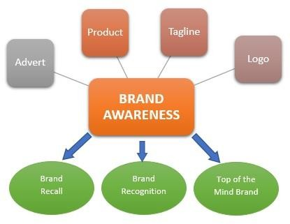

CHAPTER-5

RESEARCH METHODOLOGY

RESEARCH METHODOLOGY:
Topic Name: “A Study on Brand Awareness of JCB with Reference to Sri Sai Earthmovers”

Objective of the Study
- To learn about the different department in Sri Sai Earthmovers.
- Study about how automobile industries work.
- To study the brand awareness of JCB.
- To study perception of customers towards JCB machine.
- To know and attract towards brand name of JCB.
- To find out the brand with which JCB has to compete in the market.
- To study promotional activities of the Sri Sai Earthmovers.

TOOLS OF DATA COLLECTION:
A self-designed questionnaire was used (Annexure). Primary data filtered and analyzed, represented in the forms of graphs. Secondary data was also used in report such as company profile, product profile etc.

PRIMARY DATA:
- A detailed questionnaire was handed over to a chosen a sample at the field.
- Interaction with customer of Sri Sai Earthmovers.

SECONDARY DATA:
- Product broachers.
- Previous annual report.
- Internet.

Tools of Data Analysis:
Data analysis and interpretation of primary and secondary data is represented in the forms of Bar Graph.

SCOPE OF THE STUDY
The study was conducted with reference to “A Study on Brand Awareness of JCB with Reference to Sri Sai Earthmovers Vijayapur” an authorized dealer for JCB India Ltd in Vijaypur.
JCB Company has a large scope. JCB has a fast-growing business in India. In JCB business high investment high profit is there. JCB has a target market is there like construction, agriculture, waste handling etc.

LIMITATION OF THE STUDY
- Time constraints has prohibited from going deep into the study
- The information obtained or the collection of data is limited
- The study is restricted to Vijaypur only
- The information provided by respondent could be biased

SAMPLING SIZE
A sample size of 100 respondents was covered. Non-Probability – Convenience sampling procedure of survey was conducted during the collection of primary data. Respondents were consulted at the field and showroom.

CHAPTER-6

DATA ANALYSIS AND INTERPRETATION

Are you aware of the JCB Brand?

Particular | No of  Respondents | Percentages
Yes | 96 | 96%
No | 4 | 4%
Total | 100 | 100%

Chart 1: Are you aware of the JCB Brand
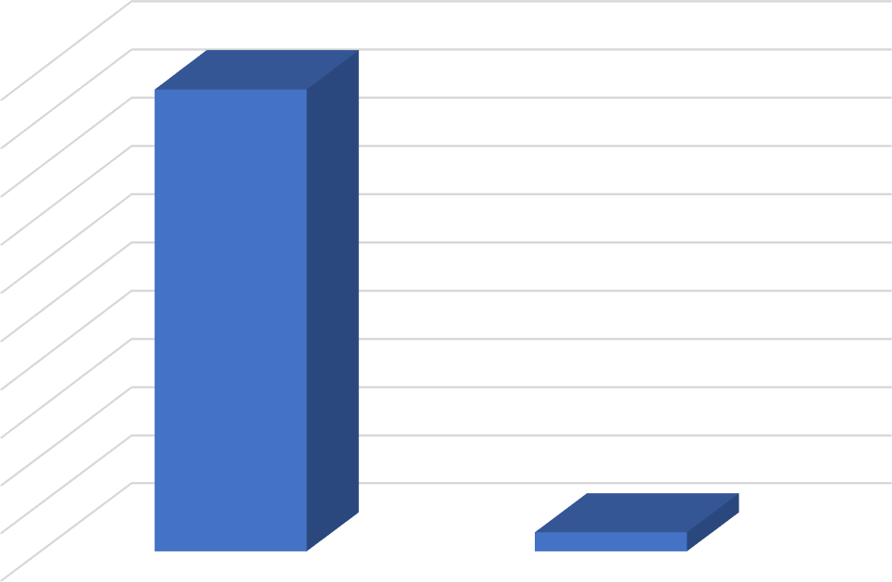
100%
90%
80%
70%
60%
96%
50%
40%
30%
20%
10%
4%
0%
Yes
No

Interpretation:
From the data and data analysis we found out of 100 respondents 96(96%) people are known about JCB brand. only 4(4%) people are not aware about JCB Brand.

Have you visited Sri Sai Earthmovers in Vijaypur?

Particular | No of Respondents | Percentage
Yes | 32 | 32%
No | 68 | 68%
Total | 100 | 100%

Chart 2: Have you visited Sri Sai Earthmovers in Vijaypur
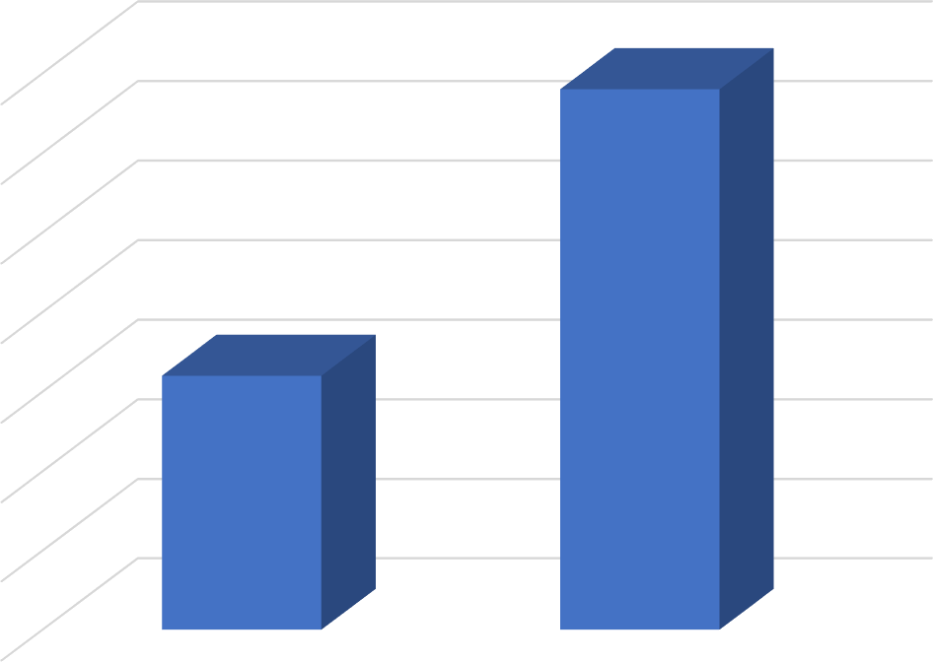
70%

60%

50%

40%
68%
30%

20%
32%
10%

0%
Yes
No

Interpretation:
From above graph & table shown about visited people in Sri Sai Earthmover in Vijayapur where out of 100 respondent 68% people are visited and 32% where not visited.

How do you come to know about the JCB brand?

Particular | No of Respondent | Percentages
Sale promotion | 23 | 23%
Advertisement | 38 | 38%
Friends and Relatives | 0 | 0%
Others | 39 | 39%
Total | 100 | 100%
Chart 3: How do you come to know about the JCB brand
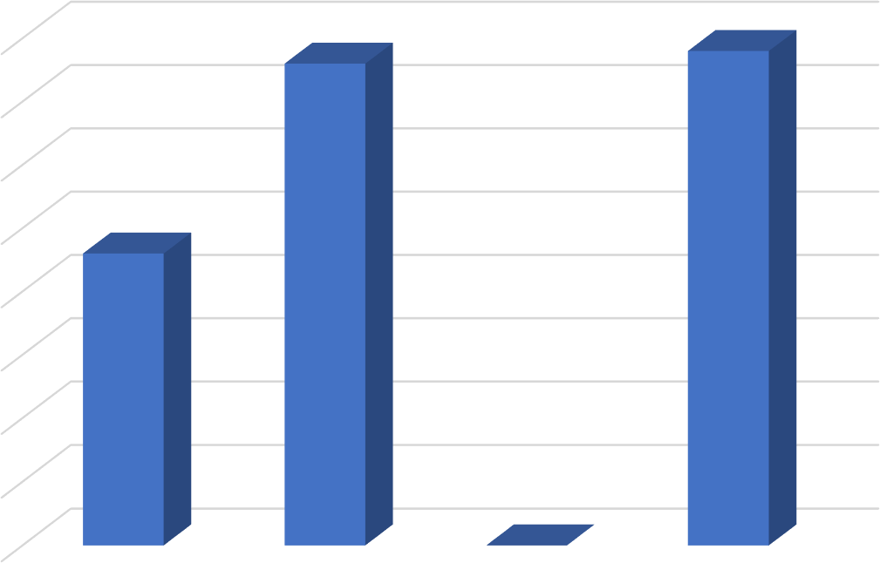
40%

35%

30%

25%

20%
38%
39%
15%
23%
10%

5%
0%
0%
Sale promotion
Advertisement Friends and Relatives
Other
Interpretation:
From the above graph and table out of 100 respondents the majority of costumer are known JCB brand through other and advertisement that is 39% and 38% where as 23% from sale promotion and friends and relatives is 0%.

If Advertisement, mention the type?

Particular | No of Respondent | Percentage
Hoardings | 18 | 18%
TV Advertisement | 25 | 25%
Wall panting | 8 | 8%
Newspaper | 49 | 49%
Total | 100 | 100%

Chart 4: If Advertisement, mention the type
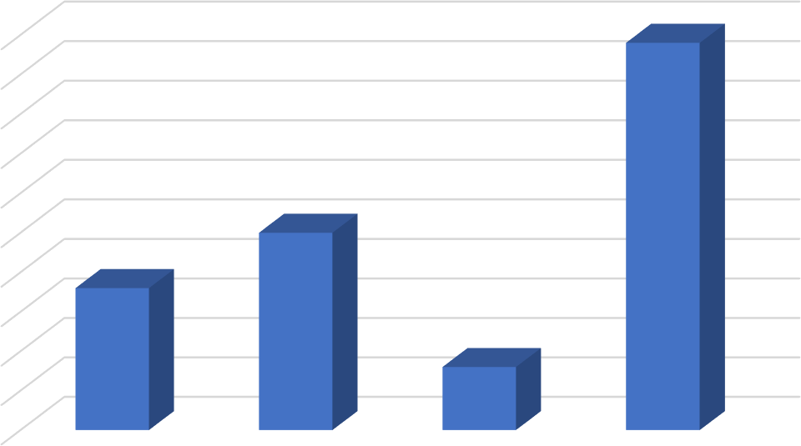
49%
5%
8%
0%
Hoardings
TV Advertisement
Wall panting
Newspaper
50%
45%
40%
35%
30%
25%
20%
15% |  | 25%
10% | 18%

Interpretation:
From the above chart and table out of 100 respondents 18% of people are known through hoardings, 25% of people through TV Advertisement, 8% of the people through wall panting, 49% of people through newspaper.

When you think to buying digging machine which come to your top choice?

Particular | No of Respondents | Percentages
L AND T | 19 | 19%
Caterpillar | 8 | 8%
Komatsu | 19 | 19%
JCB | 54 | 54%
Total | 100 | 100%
Chart 5: When you think to buying digging machine which come to your top choice
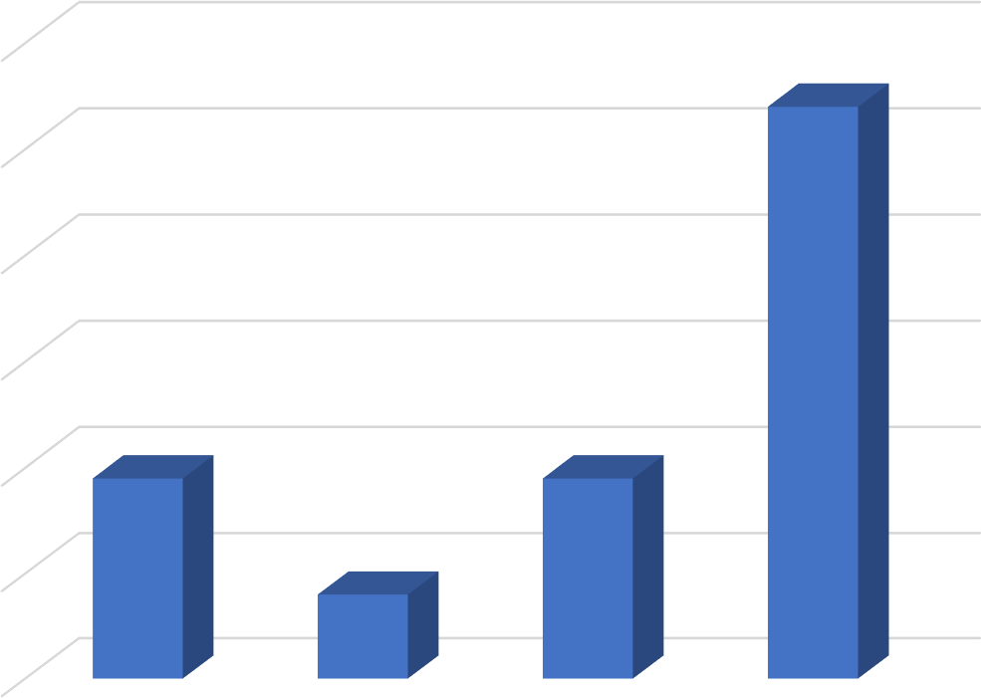
60%
50%
40%
30%
54%
20%
10%
19%
19%
8%
0%
L AND T
Caterpillar
Komatsu
JCB

Interpretation:
from the above graph and table we noticed that when they think the digging machine there first choice is JCB to purchase as 54% where as 19% given to LandT and Komatsu where as 8% to caterpillar.

Are you aware of JCB having Generator machine?

Particular | No of Respondents | Percentages
Yes | 23% | 23%
No | 77% | 77%
Total | 100 | 100%
Chart 6: Are you aware of JCB having Generator machine
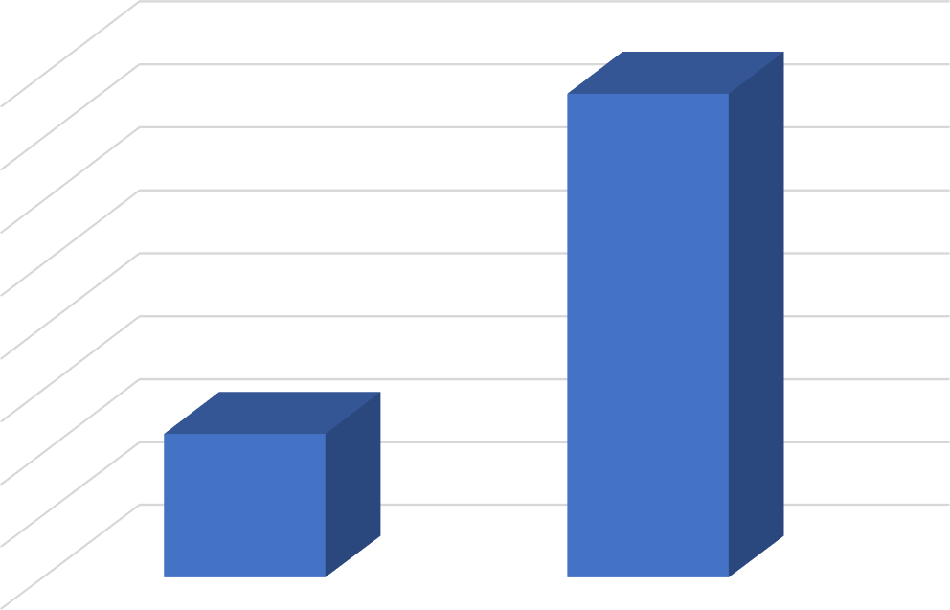
80%

70%

60%

50%
77%
40%

30%

20%
23%
10%

0%
Yes
No

Interpretation:
From the above graph and table most of people are not aware of JCB is selling the generator machine. 77% of people are not aware, 23% of people are aware about generator machine.

Which of these aspects let you to use JCB?

Particular | No of Respondents | Percentages
Availability | 14 | 14%
Personal Experience | 19 | 19%
Price | 8 | 8%
Quality | 34 | 34%
Recommendation | 25 | 25%
Total | 100 | 100%
Chart 7: Which of these aspects let you to use JCB
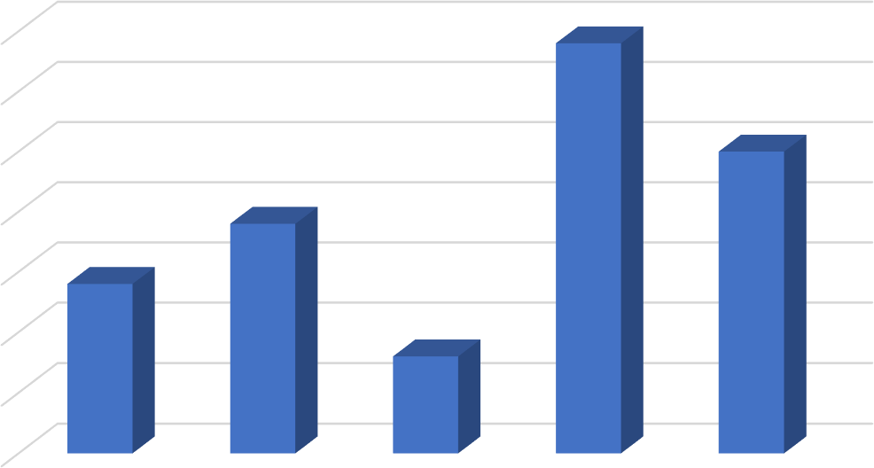





35%

30%

25%

20%
34%
15%
25%
10%
19%
14%
5%
8%
0%
Interpretation:
From the above table and graph, we noticed that majority of people are prefer quality that is 34%. 25% are purchase by recommendation. 19% are prefer personal experience.14% are prefer availability. Lastly 8% of people will prefer price.

If you used JCB machine before, which model?
Particular | No of Respondents | Percentages
3DX Xtra eco xpert | 19 | 19%
JS140 | 38 | 38%
JS220 | 22 | 22%
Escort | 14 | 14%
JCB generator | 7 | 7%
Total | 100 | 100%
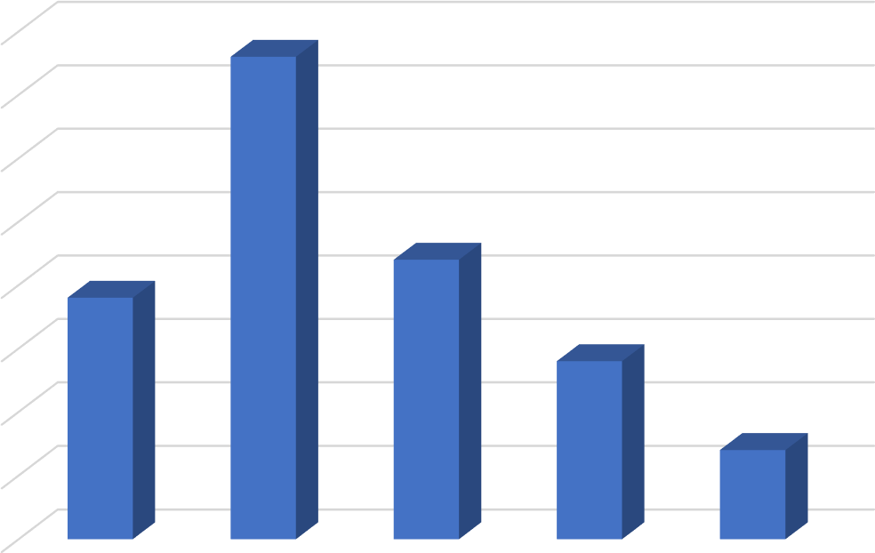
Chart 8: If you used JCB machine before, which model
40%

35%

30%

25%

20%
38%
15%
22%
10%
19%
14%
5%
7%
0%
3DX Xtra eco
xpert
JS140
JS220
Escort
JCB genrator
Interpretation:
From the above graph out of 100 respondents we noticed that majority of respondents are used 38% are used JCB model JS140. 22% are used JCB model JS220. 19% are used JCB model 3DX Xtra eco xpert. 14% are used JCB model Escort. 7% are used JCB generator.

What factor do you consider while purchasing this JCB?

Particular | No of Respondents | Percentage
Brand Image | 36 | 36%
Service | 47 | 47%
Availability | 4 | 4%
All of above | 13 | 13%
Total | 100 | 100%

Chart 9: What factor do you consider while purchasing this JCB

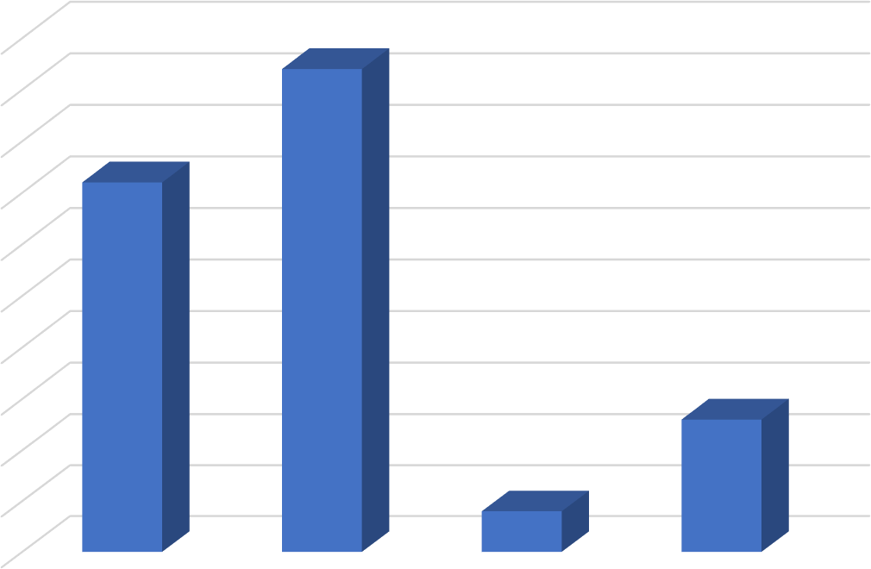
5%
4%
0%
Brand Image
Service
Avaliblity
All of above

50%
45%
40%
35%
30%
25% |  | 47%
20% | 36%
15%
10% |  |  | 13%
Interpretation:
Form the above graph out of 100 respondents most of respondents are consider that service is important while purchasing the JCB that is 47%. Second most consideration given 36% for the Brand Image.13% is given All of Above and list choice is given for the Availability that is 4%.

How much satisfied with JCB Brand?

Particular | No of Respondents | Percentages
Very satisfied | 56 | 56%
Satisfied | 32 | 32%
Not satisfied | 12 | 12%
Disappointed | 0 | 0%
Total | 100 | 100%

Chart 10: How much satisfied with JCB Brand
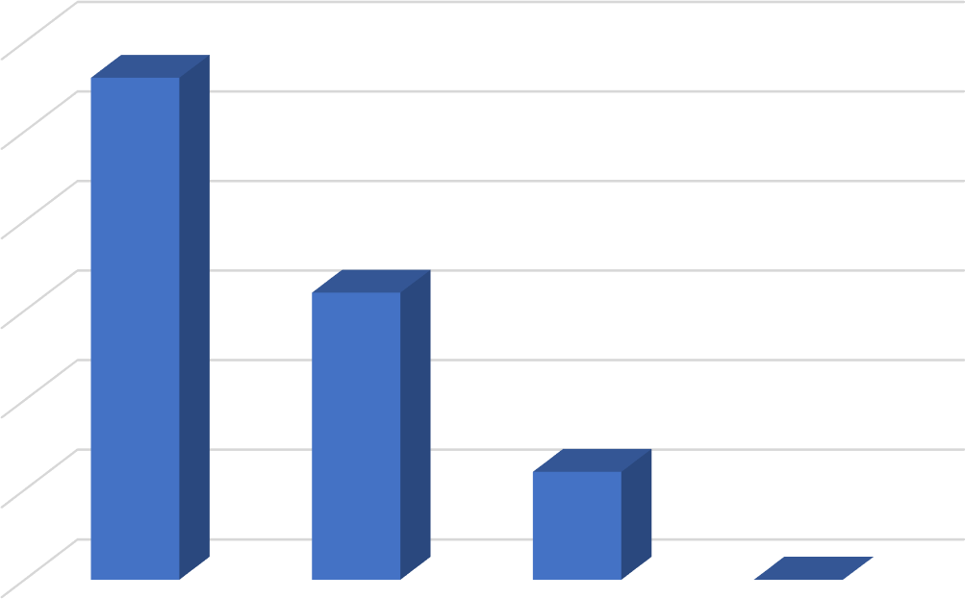
60%
50%
40%
30%
56%
20%
32%
10%
12%
0%
0%
Very satisfied
Satisfied
Not satisfied
Disapponted

Interpretation:
From the above graph out of 100 respondents we consider that JCB brand made good impact towards the customer. 56% of respondents are very satisfied with JCB brand. 32% are satified.12% are not satisfied and no one are disappointed that is 0%.

Are you aware of JCB is giving festival offers?

Particular | No of Respondents | Percentages
Yes | 54% | 54%
NO | 46% | 46%
Total | 100 | 100%
Chart 11: Are you aware of JCB is giving festival offers
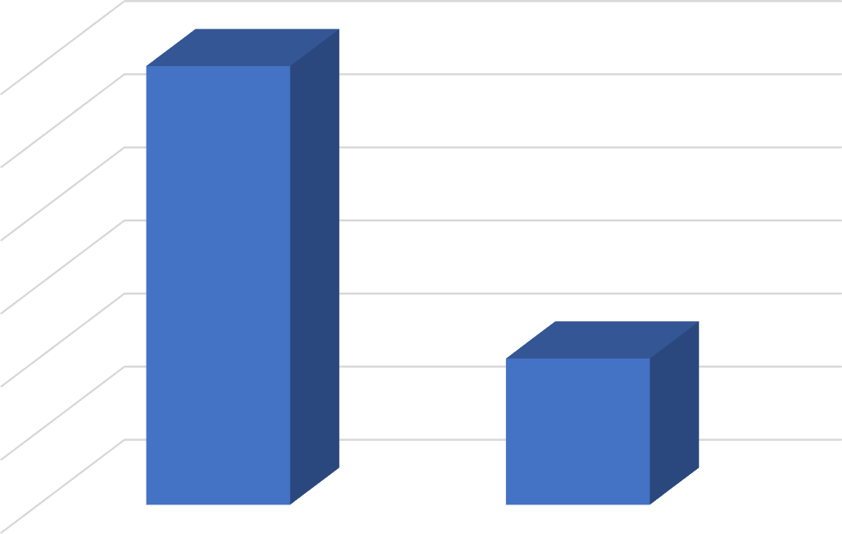
54%
52%
50%
54%
48%
46%
46%
44%
42%
Yes
NO

Interpretation:
From the above graph out of 100 respondents aware of festival offer are respondents are 54% given as yes and 46% of respondents given as No.

What is the main purpose of using JCB machine?

Particular | No of Respondents | Percentages
Agriculture purpose | 32% | 32%
Commercial purpose | 68% | 68%
Total | 100 | 100%

Chart 12: What is the main purpose of using JCB machine
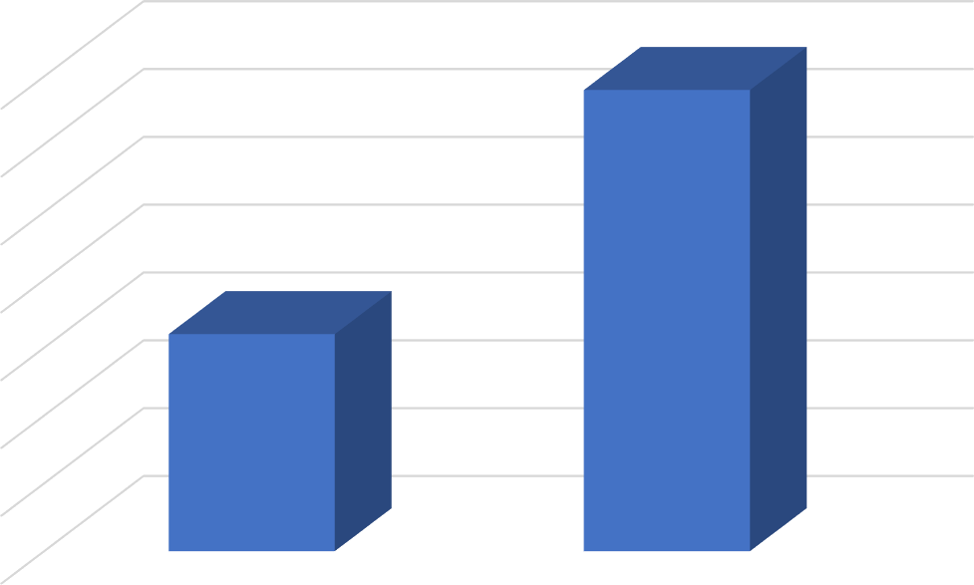
70%

60%

50%

40%
68%
30%

20%
32%
10%

0%
Agriculture purpose
Commercial purpose

Interpretation:
From the above graph and table out of 100 respondent’s majority of people are used for the commercial purpose for JCB as 68% and 32% people are used for the agriculture.

Overall rating of JCB Machine?

Particular | No of Respondents | Percentages
Excellent | 78 | 78%
Good | 16 | 16%
Average | 6 | 6%
Poor | 0 | 0%
Total | 100 | 100%

Chart 13: Overall rating of JCB Machine
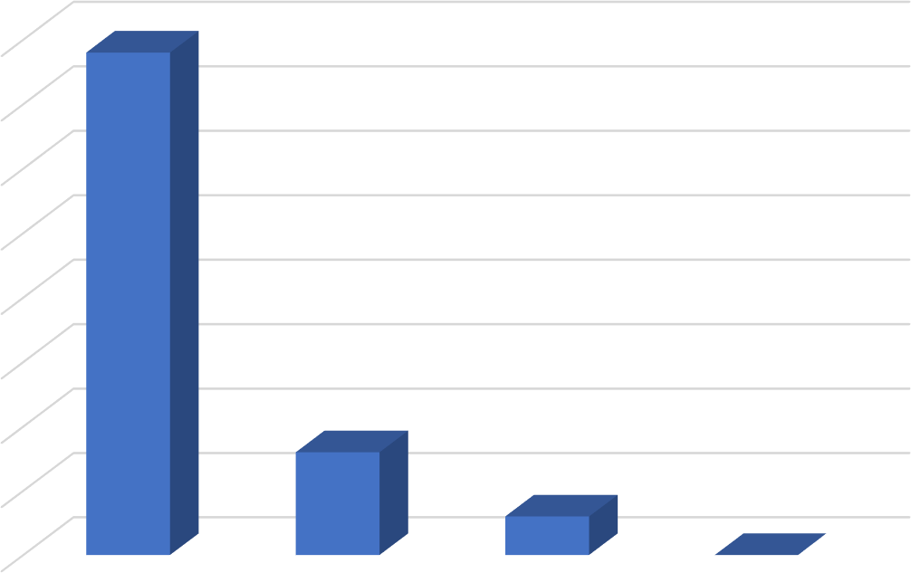
80%

70%

60%

50%

40%
78%
30%

20%

10%
16%
6%
0%
0%
Excellent
Good
Average
Poor

Interpretation:
From the above graph out of 100 respondents, majority of respondents are given rating excellent for the JCB machine it shows that JCB has providing goods service to the costumer.78% are given excellent.16% are given good.6% are given Average and 0% are given for poor.

Which of the following, according to you, help to build brand image?

Particular | No of Respondents | Percentages
Quality | 43% | 43%
Added service | 26% | 26%
Competitive price | 24% | 24%
Good value | 7% | 7%
Total | 100 | 100%

Chart 14: Which of the following, according to you, help to build brand image
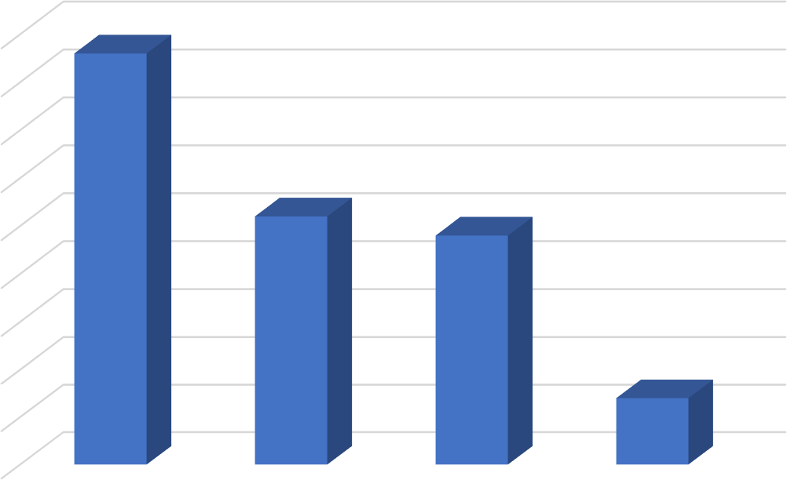
24%
7%
0%
Quality
Added service
Competitive price
Good value
45%
40%
35%
30%
25% | 43%
20%
15% |  | 26%
10%
5%

Interpretation:
From the above graph out of 100 respondents feels that quality is important to build a good brand image given as 43%, where as 26% for added service, 24% given to competitive price and 7% given to good values.

Do you like to recommended your friends and relatives to purchase JCB machine?

Particular | No of Respondents | Percentages
Very likely | 56 | 56%
Likely | 32 | 32%
Somewhat likely | 10 | 10%
Not at all | 2 | 2%
Total | 100 | 100%
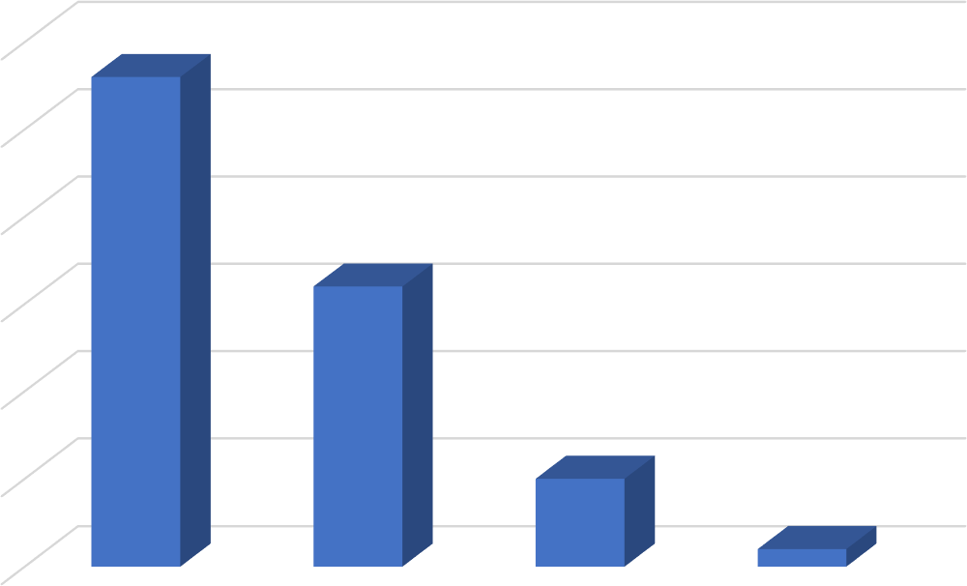
60%
50%
40%
30%
56%
20%
32%
10%
10%
2%
0%
Very likely
Likely
Some what likely
Not at all
Chart 15: Do you like to recommended your friends and relatives to purchase JCB machine
Interpretation:
From the above graph out of 100 respondents most of respondents wants recommend the JCB given as very likely 56% where as likely 32%, somewhat likely 10% and not at all 2%.

Are you interested JCB in the future?
Particular | No of Respondents | Percentages
Yes | 88 | 88%
No | 12 | 12%
Total | 100% | 100

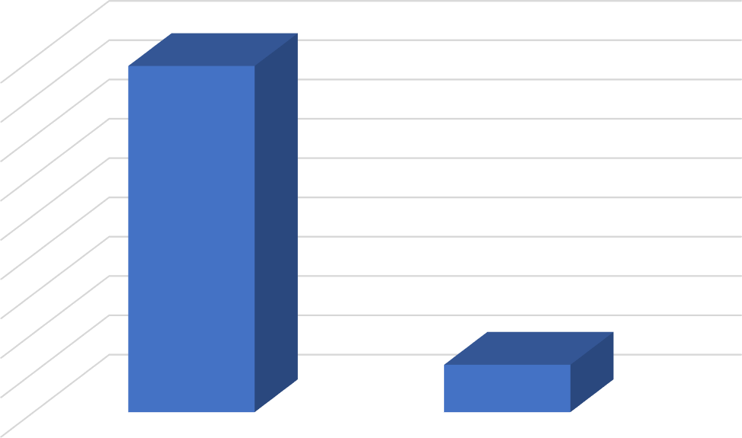
12%
No

90%
80%
70%
60%
50% |  | 88%
40%
30%
20%
10%
0% | Yes

Chart 16: Are you interested JCB in the future
Interpretation:
From the above graph out of 100 respondent’s majority of respondents are they want to use JCB machine that is 88% and 12% of would not want use JCB machine.

CHAPTER -6

FINDINGS, SUGGESTION AND CONCLUSION

FINDINGS
  - From the survey we found that 96% of the respondents are aware about the JCB.
  - From the survey we found that 32% of the respondents are visited to the Sri Sai Earthmovers in Vijayapur.
  - By the survey we found that for the 39% are known for the other and 38% from advertisement this show that JCB has crated brand image on the customer mind.
  - By the survey we found that 49% respondents are know from Newspaper this show company have spending money on advertisement.
  - 54% of respondents feels that when they think to buy a digging machine their first choice will be JCB.
  - From the study we found that 77% are aware about the generator JCB machine
  - From the study we found that 34% respondents are prefer Quality.
  - From the study we found that majority of respondents are used JS140 JCB model as a 38%.
  - 47% of respondents are while purchasing JCB they consider good service is important.
  - From the study we found that JCB has created good relationship with costumer because 56% respondents are very satisfied JCB brand.
  - From the study we found that 54% of respondents are aware about festival offer which given by JCB.
  - From the study we found that 64% respondents are used JCB for the commercial purpose.
  - 78% of respondents are given rating that JCB machine have given the excellent performance.
  - From the above survey we found that 43% of respondents are given that to build good brand image Quality is important.
  - From the above survey we found that 56% of respondents are very likely recommend JCB.
  - From the study we found that 88% of the respondents are using JCB in the future.

SUGGESTIONS
  - From the survey we found that most of respondent want to use JCB in the future so company have to focused increase the costumer and retain the customer.
  - The usage of the generator is below average, the company should concentrate on increase the awareness of the product.
  - company has given the festival offers. But so many are not aware of that so company has increased the awareness about offer through different advertisement media.
  - I suggest to increase the promotional activity of JCB in the form of Tv advertisement, social media, newspaper etc. which will help create brand awareness of JCB.
  - JCB machine is not meant for everyone JCB is high-cost machine their main focused constructor, farmer who required more so they have to increase customer bases on that category so it will develop long term relationship customer.
  - JCB company as conduct the campaign in rural area and give the knowledge about JCB machine and tell them advantages JCB machine. Tell them how beneficiary to them.
  - JCB group has earned a good name Indian market as in the overseas. All they need to maintained the goodwill and the prestige they have earned.

CONCLUSION
As per my study “A Study on Brand Awareness of JCB Reference to Sri Sai Earthmovers”
From an accomplishing project I have gained excellent knowledge. This project helped me to know the view of customer and common people towards JCB brand.
I would say that the purpose of this project is to know the brand awareness of JCB in Vijaypur. Despite of small sample of questionaries we come to know the view of customer towards JCB brand in Vijaypur.
From the survey we conclude that JCB has created good brand awareness among people. JCB has built its brand awareness among relatively large number of people in around Vjayapur. But lack in rural customer. So, Company has to focus on the brand awareness in the rural area and developing brand awareness in rural customer. JCB has created a trust among the people. And all the promotional tools such as newspaper, magazine, Holdings has done regularly and also Sri Sai Earthmovers are giving best offers to the customer. which create good brand image for the costumer.
Lastly in this project conclude that most of respondents are satisfied with JCB brand and service which is provided by Sri Sai Earthmovers.

CHAPTER

BIBLIOGRAPHY

BIBLIOGRAPHY & REFERENCES:

- Philip Kotler and Garry Armstrong: Principles of Marketing: 12th Edition: Prentice-Hall of India Pvt. Ltd.
- S H H Kazmi and Satish K Batra: Advertising and Sales Promotion: 3rd
Edition: Excel Books
- Harsha V Verma: Brand Management- Text and Cases: 2nd Edition: Excel Books
- C R Kothari: Research Methodology: 2nd Edition: New International Publication

Website
- www.JCB.in
- www.scribd.com

CHAPTER

QUESTIONNAIRE

ANNEXURES:
- Are you aware of the JCB brand? Yes  No

- Have you visited Sri Sai Earthmovers in Vijayapur? Yes  NO

- How do you come to know about JCB?
Sale promotion  Advertisement
Other  Friends and relatives

- If advertisement, mention the type?
Holdings  Tv advertisement
Wall paintings Newspaper

- When you think to buying a digging machine, which come to your top choice? Caterpillar  Komstsu
L and T  JCB

- Are you aware of JCB having Generator machine? Yes  No

- Which of the aspect let you use JCB?
Personal experience  Recommendation 
Price Quality Availability

- If you used JCB before, which model? JS 140  JS220 
Escoat  3DX  Generator

- Which of the factor consider while purchasing JCB? Brand Image  Price
Availability  Quality

- How much satisfied with JCB machine? Very satisfied  Satisfied
Good  Disappointment Poor

- Are you aware JCB is giving festival offers? Yes  No

- What is main the purpose of using JCB machine? Agriculture purpose  commercial purpose

- Overall rating of JCB machine? Excellent  Average
Good  Poor

- Which of the following, according to you, help to build brand image? Quality  Added service
Competitive price  good value

- Do you like to recommended your friends and relatives to purchase JCB machine?
Very likely  Somewhat likely

